Requirement Analysis
Data Flow Diagram & User Stories
Date | 19 Feb 2026
Team ID | LTVIP2026TMIDS39481
Project Name | ShopSmart: Your Digital Grocery Store Experience

Data Flow Diagram (DFD) :

A Data Flow Diagram (DFD) is a graphical representation of how data moves through a system. It shows the flow of data between processes, external entities, and data stores in a system without showing program logic or internal data structures.
Why Use a DFD?
- It provides a clear overview of how the system handles data.
- Useful for analyzing and designing the system architecture.
- Helps identify inputs, outputs, processes, and data storage in a system.

Components in a DFD
- External Entities: Represent users or systems that interact with the application.
- Processes: Represent tasks/functions performed by the system.
- Data Stores: Databases or storage that hold data.
- Data Flows: Arrows that show the movement of data between entities, processes, and stores.

Example (Simplified Flow for ShopSmart):
Customer --> [Login/Register] --> [Authentication Process] --> [User Database]
Customer --> [Browse Products] --> [Product Search Process] --> [Product Database]
Customer --> [Add to Cart] --> [Cart Process] --> [Cart Database]
Customer --> [Checkout] --> [Order Process] --> [Order Database]
Admin --> [Manage Products] --> [Product Management Process] --> [Product Database]
Data Flow Diagram (DFD):

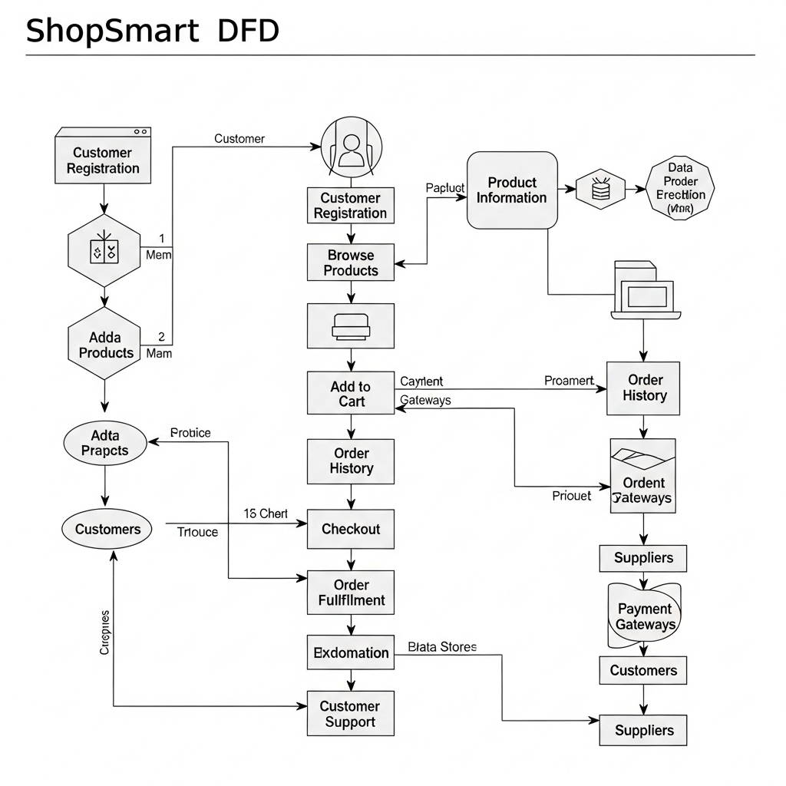
User Stories Table:

User Type | Functional Requirement (Epic) | User Story Number | User Story / Task | Acceptance Criteria | Priority | Release
Customer (Mobile user) | Registration | USN-1 | As a user, I can register for the application by entering my email, password, and confirming my password. | I can access my account / dashboard | High | Sprint-1
 |  | USN-2 | As a user, I will receive a confirmation email once I have registered for the application. | I can receive a confirmation email & click confirm | High | Sprint-1
 |  | USN-3 | As a user, I can register for the application through Facebook. | I can register & access the dashboard via Facebook | Low | Sprint-2
 |  | USN-4 | As a user, I can register for the application through Gmail. | I can register & access via Gmail | Medium | Sprint-1
 | Login | USN-5 | As a user, I can log into the application by entering my email & password. | I can access the system securely | High | Sprint-1
Customer (Web user) | Product Search & Order | USN-6 | As a user, I can browse and search products using category and price filters. | I can view filtered product results | High | Sprint-2
 |  | USN-7 | As a user, I can add products to my cart and adjust quantities. | My cart updates dynamically | High | Sprint-2
 |  | USN-8 | As a user, I can place orders with a selected payment method. | I get a success message and confirmation email | High | Sprint-2
Seller | Product Management | USN-9 | As a seller, I can log in to my dashboard and manage my product listings. | I can add/edit/delete products | High | Sprint-3
 |  | USN-10 | As a seller, I can view and track customer orders. | I see a list of customer orders | Medium | Sprint-3
Admin | Admin Dashboard | USN-11 | As an admin, I can approve or deactivate sellers. | I can manage seller status from dashboard | High | Sprint-3
 |  | USN-12 | As an admin, I can manage product listings and user accounts. | I can add/edit/delete any products or users | High | Sprint-3

